### **Korzo - Manufacturing management**

#### **Curtain Product Configuration**

We need to create **two separate curtain products** to support different BOM (Bill of Materials) types:

1. **Curtain Product (Motorised Wave Curtain) (Kit-type BOM)** – Used for sales order line selection.
2. **Curtain Product (Motorised Wave Curtain - Manufacture) (Manufacturing-type BOM)** – Used for manufacturing purposes.

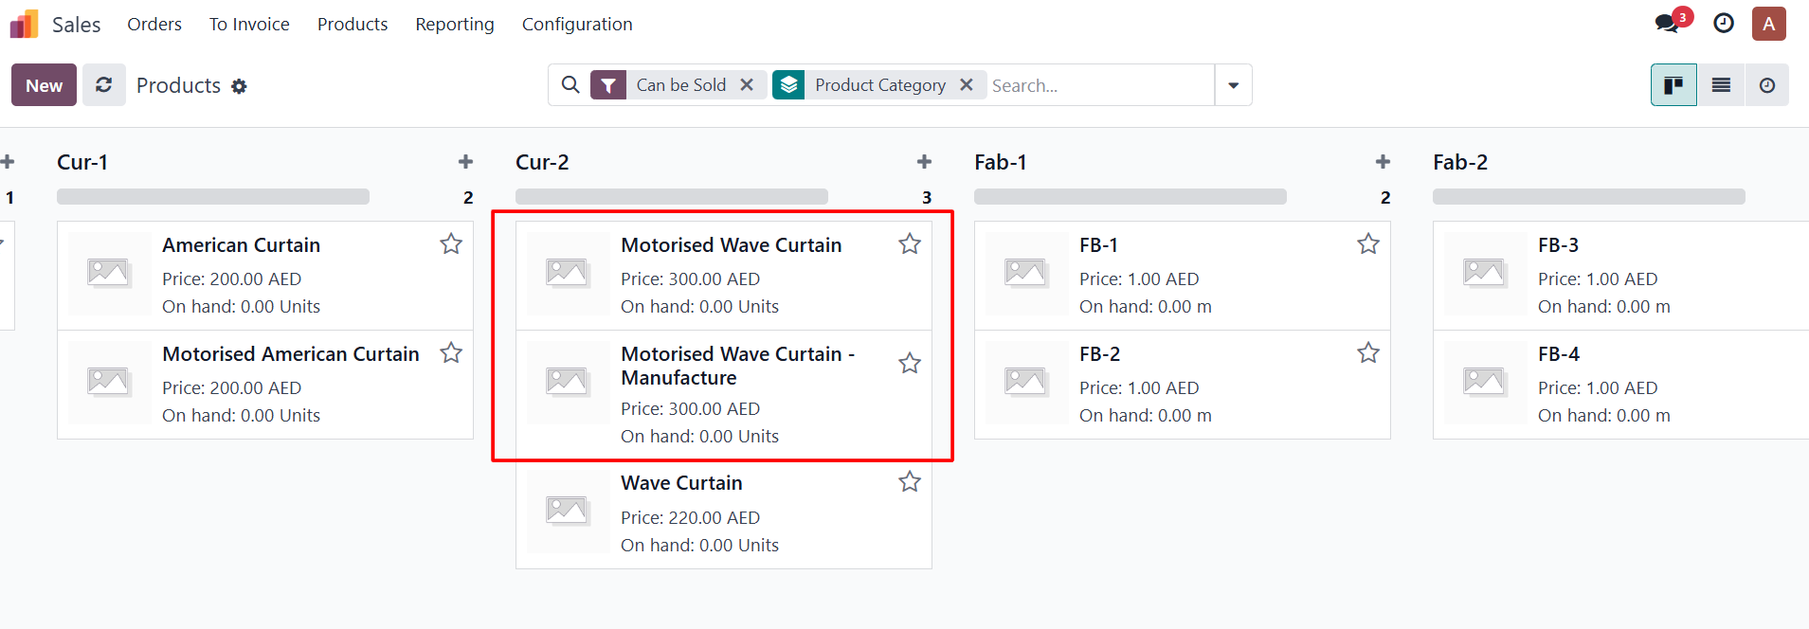

* Always keep checkbox “Is Manufactured” True in manufacture product (**Motorised Wave Curtain - Manufacture)**

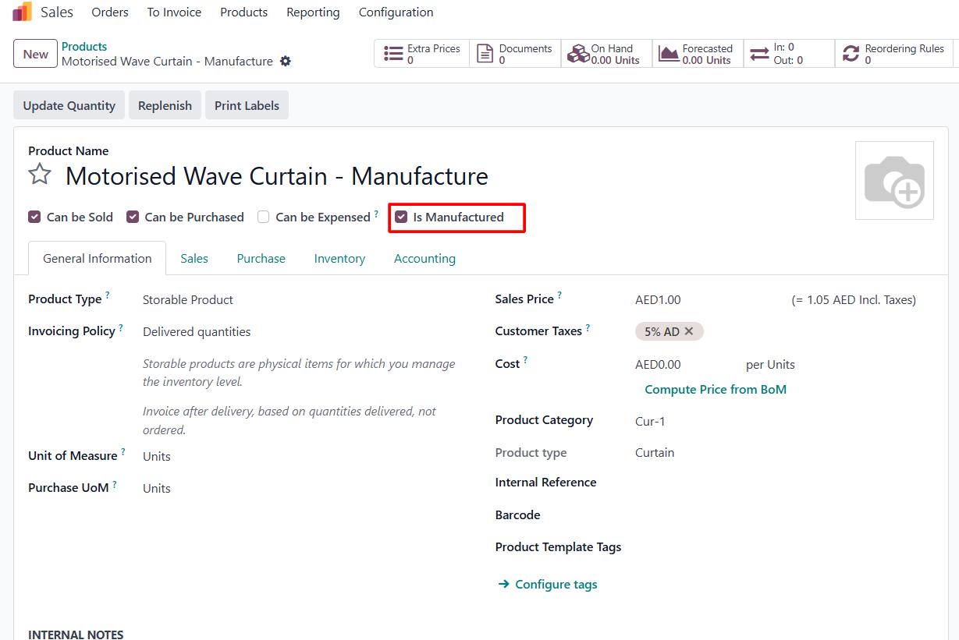

* You need to create BOM for manufacture product (**Motorised Wave Curtain - Manufacture**) without components.

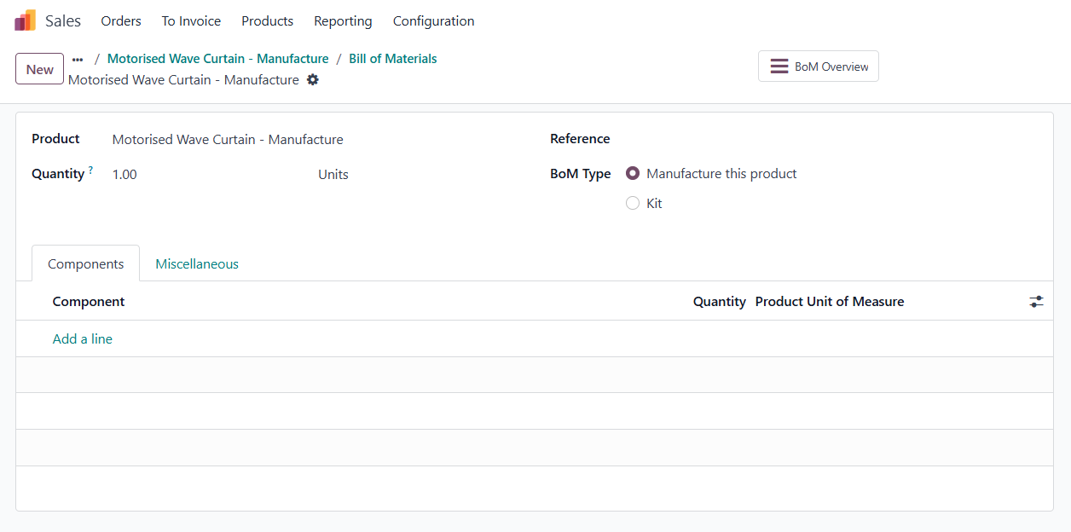

* Then set this product into the main curtain product **(Motorised Wave Curtain) (Kit-type BOM).**

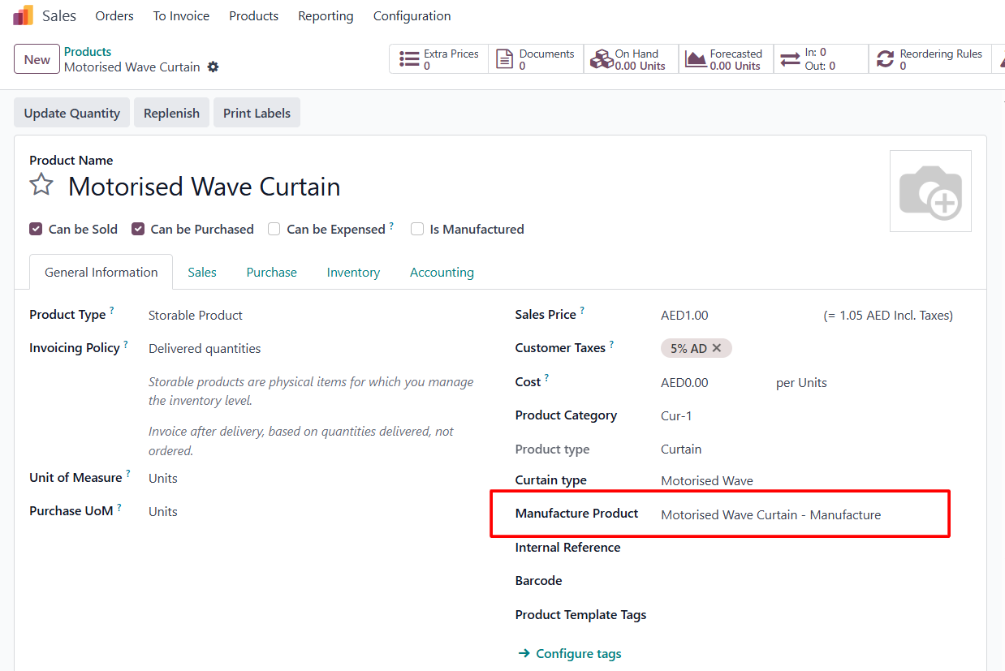

#### **Sale Order Process**

On the **sales order**, the user will select the **main curtain product** (with a *kit-type BOM*).

Additional components such as

* **Fabric product**
* **Track product**
* **Motor (if required)**

will also be added to the sales order lines.

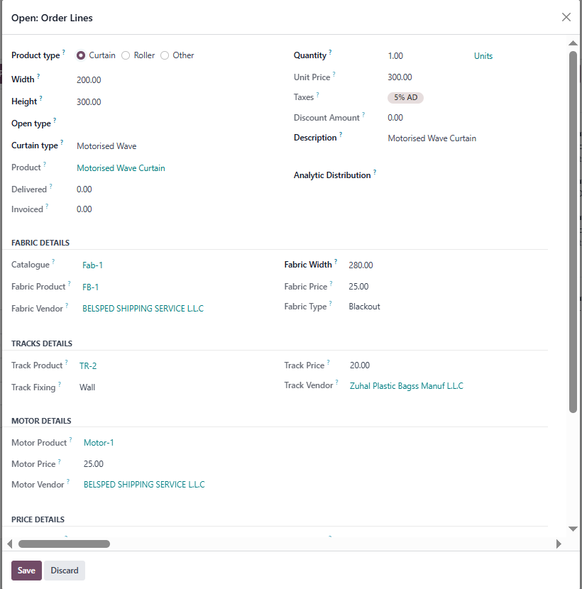

#### **Manufacturing Order Creation**

* + Upon **confirmation of the sales order**, a **manufacturing order (MO)** will be automatically created for the **manufacturing-type BOM curtain product (Motorised Wave Curtain - Manufacture)**.

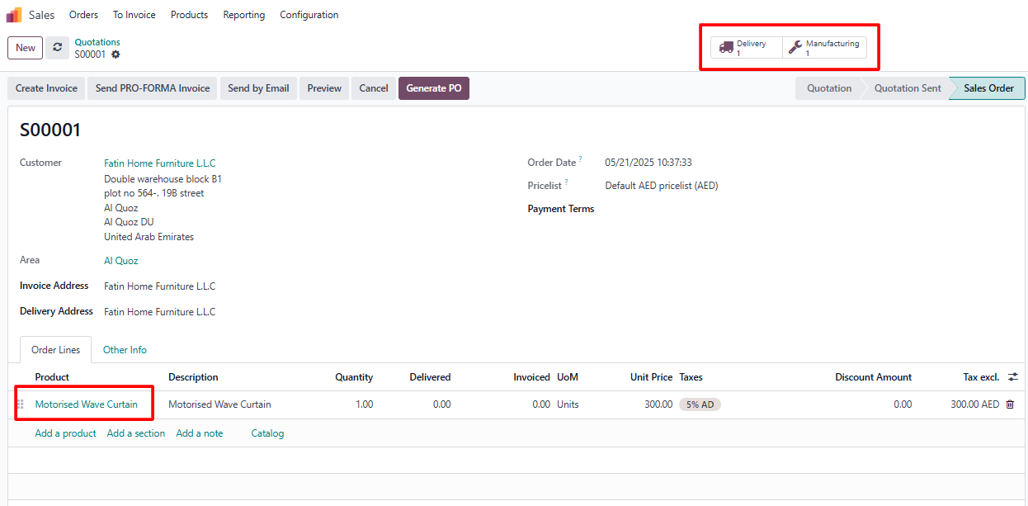

* + The MO will include the **fabric product (**FB-1) that was selected in the sales order line as a component.

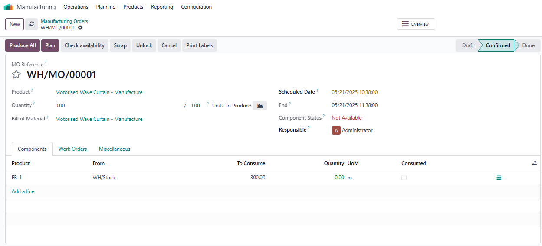

* + This MO will also generate **work orders** with **Start** and **Stop** buttons for tracking production progress.

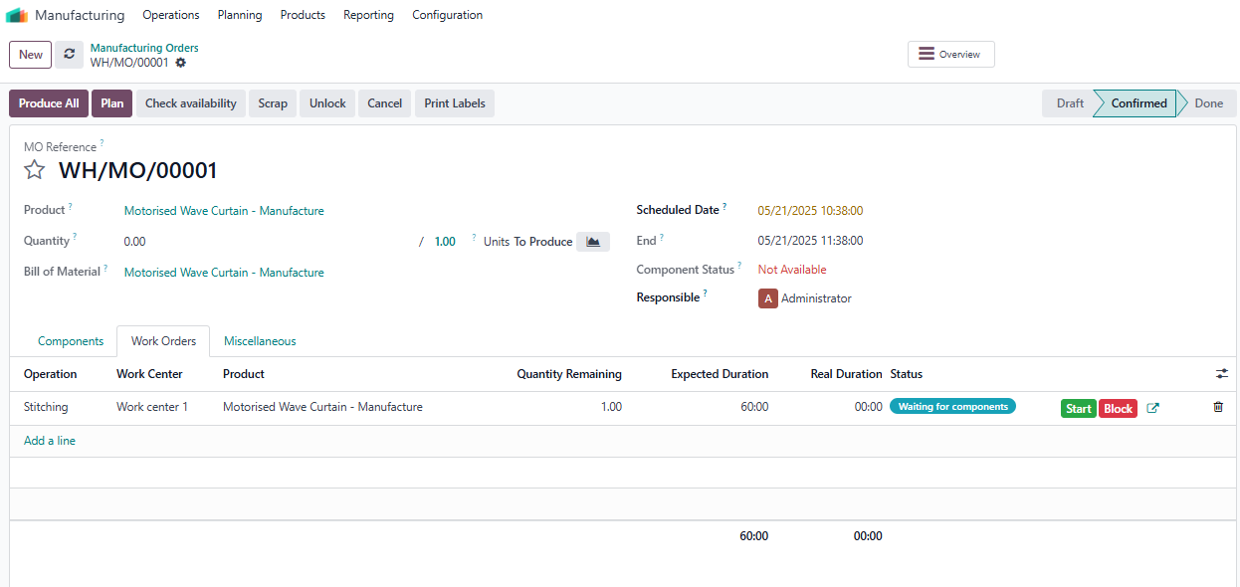

#### **Kit-type BOM Handling**

* Each time a sales order is confirmed:
  + A **kit-type BOM** will be created dynamically.
  + The **Track (TR-2)**, **Motor (Motor-1)**, and **Fabric (FB-1)** products (as selected in the sales order) will be added as **components** of this BOM.
  + A **delivery order** will be created for these components, enabling the shipment of the curtain kit.

